Authentication vs Authorization
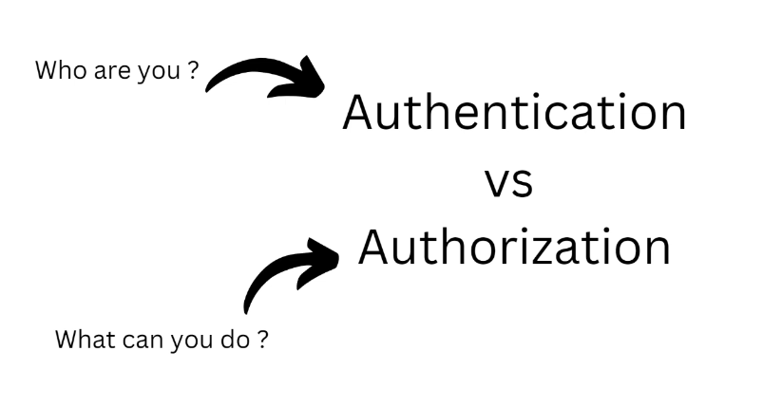
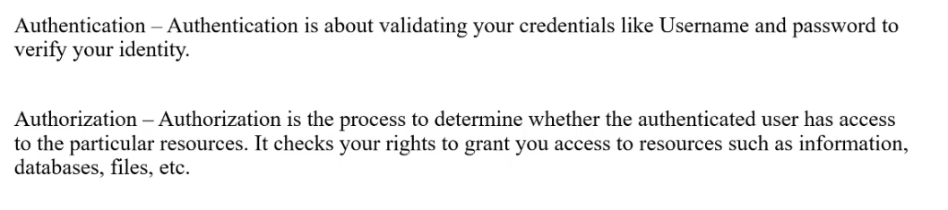

TYPES OF AUTHENTICATIONS

1. Password-Based Authentication
The most common method where users log in using:
- Username / Email
- Password
Ex: Logging into:
  - Gmail, LinkedIn, Company portal
2. Multi-Factor Authentication (MFA)
Uses multiple layers of verification:
- Something you know → Password
- Something you have → OTP / Phone
- Something you are → Biometrics
Example
- Login → enter password
- Then → enter OTP sent to mobile

3. One-Time Password (OTP) Authentication
Login using a temporary code sent via:
- SMS
- Email
- Authenticator app
Example
- Logging into banking apps
- “Login with OTP” option

4. Biometric Authentication
Uses biological traits:
- Fingerprint
- Face recognition
- Iris scan
Example
- Unlocking phone with fingerprint
- Face ID on apps
5. Token-Based Authentication
After login, system gives a token (like a pass)
User uses that token for future requests
Example
- Login → get token
- Access APIs using token

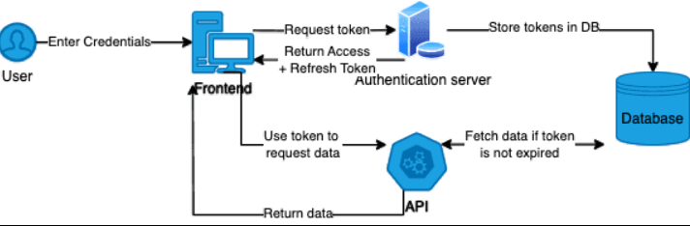

6. JWT (JSON Web Token) Authentication
A special type of token that contains:
- User identity
- Roles
- Expiry
📦 Example
- Most modern APIs (Spring Boot, microservices)
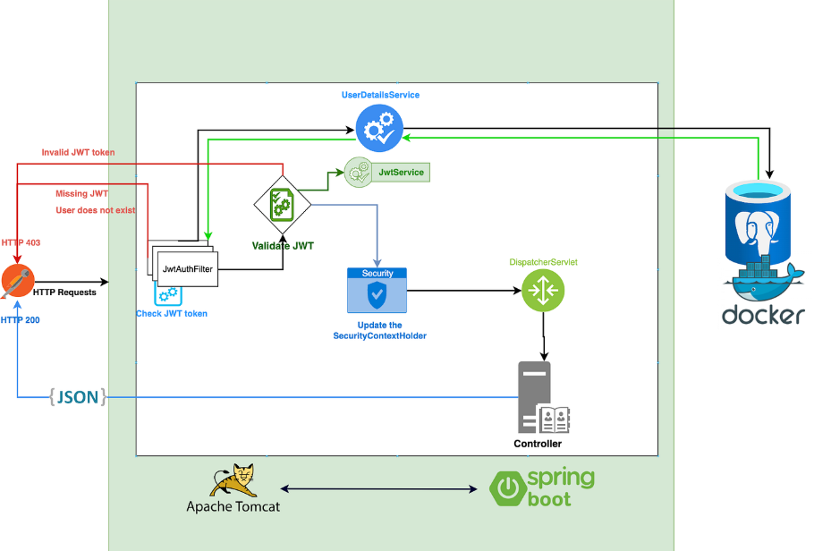

7. OAuth / Social Login
Login using another platform:
- Google
- GitHub
- Facebook
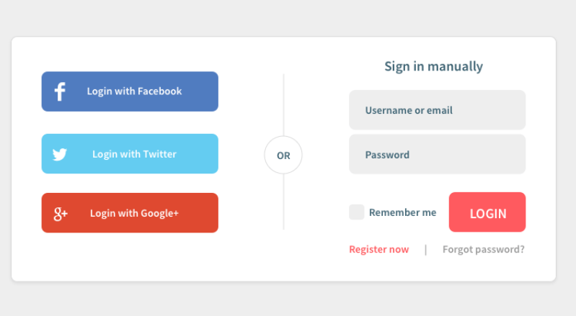

8. Session-Based Authentication
Server creates a session after login
Client stores a session ID (cookie)
Example
- Traditional web apps (banking sites)

Type | Best Use Case
Password | Basic apps
MFA | High security systems
OTP | Quick login
Biometrics | Mobile apps
JWT | APIs / Microservices
OAuth | Social login
Session | Traditional web apps

TYPES OF AUTHORIZATION

1. Role-Based Access Control (RBAC)
Access is based on roles
Example
Role | Access
USER | View data
ADMIN | View + Edit + Delete
MANAGER | Approve requests

2. Attribute-Based Access Control (ABAC)
Access based on attributes like:
- User role
- Location
- Time
- Department
Example
- Employee can access data:
  - Only during office hours
  - Only from office network

3. User-Based Authorization
Access granted to specific users
Example
- Only “Surya” can access a specific report

4. Policy-Based Authorization
Access controlled using rules/policies
Example
- “Only managers with 5+ years experience can approve budgets > 1 lakh”

5. Resource-Based Authorization
Access depends on resource ownership
Example
- You can edit:
  - Your own profile
  - Your own documents
6. Scope-Based Authorization (OAuth APIs)
Access defined by scopes
Example
- Google API:
  - read_profile
  - read_email

Type | Best Use Case
RBAC | Most applications
ABAC | Enterprise systems
User-Based | Small systems
Policy-Based | Complex workflows
Resource-Based | APIs (very important)
Scope-Based | OAuth / APIs

End-to-End Flow (Real Application)
- User enters login credentials
- Backend validates credentials
- If valid → generates JWT token
- Client stores token (localStorage / memory)
- Client sends token in every API request
- Backend validates token
- Backend checks user roles/permissions
- Allows or denies access

Authentication Flow
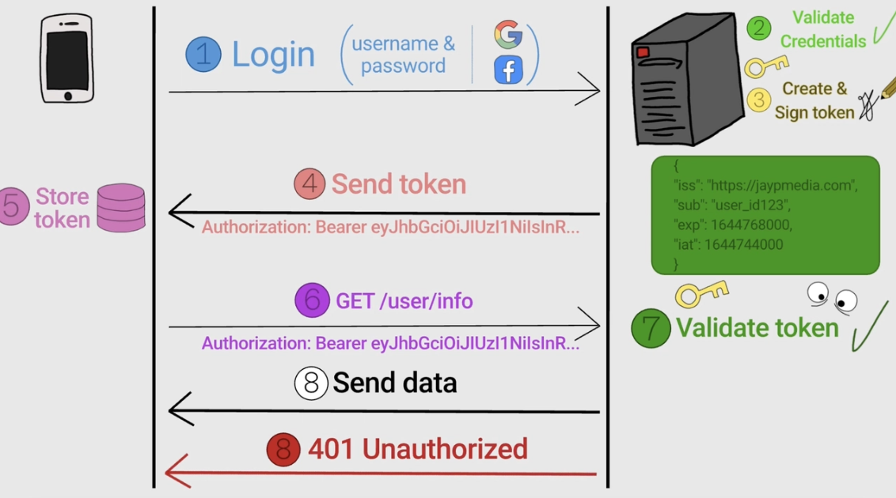
Authorization Flow
